DESIGN, CONFIGURE, ANALYZE AND EVALUATE A MULTI-BRANCH ENTERPRISE NETWORK USING IP ADDRESSING, ROUTING, PROTOCOLS AND NETWORK TOPOLOGIES FOR RELIABLE, SCALABLE, AND EFFICIENT INTER-BRANCH COMMUNICATION
Item | Details
Course Code | CSA0704
Course | Computer Networks
Course Outcomes | CO2, CO3, CO4
Bloom’s Levels | L5 – Evaluate; L6 – Create
SDG | SDG 9 – Industry, Innovation and Infrastructure
Simulation Platform | Cisco Packet Tracer
Network Scope | Head Office + 2 Branch Offices; 36 end devices
Routing Protocol | OSPF – Area 0
Addressing Method | IPv4 VLSM with VLAN segmentation

Student Details | Value
Name | S.JAGADISH
Register Number | 192421406
Department | IT
- PROBLEM STATEMENT AND PROBLEM FORMULATION
- Problem Statement
A growing organization requires a reliable and scalable enterprise computer network connecting a Head Office and two Branch Offices. The organization contains departments such as Human Resources, Research and Development, Sales, and Finance, which require continuous communication and access to shared network services.The proposed network consists of at least 36 end devices distributed among the Head Office and Branch Offices. The network uses an appropriate IPv4 addressing scheme with subnetting and VLSM, assigns suitable default gateways, and establishes basic routing between multiple network segments. The network is designed and simulated using a suitable networking simulation platform such as Cisco Packet Tracer. Star, mesh, bus, and hybrid topologies are designed and compared based on reliability, scalability, cost, fault tolerance, and performance. The project also analyzes TCP, UDP, HTTP, and DNS under different network conditions such as normal traffic, high network traffic, and link congestion or link failure. Performance parameters including latency, throughput, packet loss, delay, jitter, successful delivery rate, and recovery time are considered for engineering evaluation. The proposed enterprise network follows the general communication structure: End Devices → Switch → Router → Inter-Branch Network → Router → Switch → End Devices
Problem Formulation
The problem is to design, configure, simulate, test, and evaluate a multi-branch enterprise network thatprovides reliable communication between departments and branch offices while maintaining efficient IP,addressing, routing, topology, and protocol performance.
The system must perform the following operations:
1. Identify the organization, departments, branch offices, and end-device requirements.
2. Design a suitable enterprise network architecture.
3. Allocate IPv4 addresses to all network segments.
4. Apply subnetting and VLSM for efficient address utilization.
5. Assign suitable subnet masks and default gateways.
6. Configure routers, switches, PCs, and servers.
7. Establish routing between different network segments.
8. Verify end-to-end communication between departments and branches.
9. Design and demonstrate star, mesh, bus, and hybrid topologies.
10.Select suitable transmission media and cabling standards.
11.Configure and analyze TCP and UDP communication.
12.Configure and analyze HTTP and DNS communication.
13.Test the network under normal and high traffic conditions.
14.Introduce link congestion or link failure.
15.Observe the effect of network changes on communication.
16.Measure latency, throughput, packet loss, delay, jitter, and successful delivery.
17.Compare the observed performance under different conditions.

1. Introduction and Problem Understanding
This report presents the end-to-end design, simulation plan, and evaluation of a multi-branch enterprise network for a growing organization consisting of one Head Office (HO) and two Branch Offices (BO1 and BO2). The organization operates four departments – Human Resources (HR), Research & Development (R&D), Sales, and Finance – distributed unevenly across the three sites. The design satisfies the assignment's core requirements: at least 36 end devices, IPv4 addressing with VLSM subnetting, routing across at least four network segments, demonstration of star, mesh, bus, and hybrid topologies, and analysis of TCP, UDP, HTTP, and DNS behaviour under normal, high-traffic, and failure/congestion conditions.
1.1 Organization Profile
Site | Departments Present | End Devices | Role
Head Office (HO) | HR, R&D, Sales, Finance, Server Farm | 28 | Headquarters; hosts core router, DNS & HTTP servers, primary internet edge
Branch Office 1 (BO1) | Sales, Finance | 8 | Regional sales/finance branch
Branch Office 2 (BO2) | HR, R&D | 6 | Regional HR/R&D branch

1.2 Objectives
- Design an efficient, low-waste IPv4 addressing scheme using VLSM across at least four network segments.
- Establish reliable inter-branch routing with fast convergence and a redundant path.
- Design and justify star, mesh, bus, and hybrid topologies, selecting the most suitable overall design.
- Configure and test TCP, UDP, HTTP, and DNS traffic under normal load, high load, and link failure/congestion.
- Measure latency, throughput, packet loss, delay, jitter, delivery rate, and fault-recovery time, and identify bottlenecks.
- Document engineering decisions and broader considerations (scalability, reliability, standards, professional responsibility).

2. Requirements Analysis
2.1 Users, Departments and Host Count
A minimum of 36 end devices is required by the brief. This design allocates 42 end devices across nine department/segment groupings plus a two-node server farm, giving headroom for growth while keeping subnet sizes efficient (see Section 4).
Segment | Site | End Devices | Device Types
HR LAN | HO | 6 | PCs, 1 printer
R&D LAN | HO | 8 | PCs, workstations, 1 lab printer
Sales LAN | HO | 6 | PCs, laptops
Finance LAN | HO | 6 | PCs, 1 printer
Server Farm | HO | 2 | DNS server, Web/HTTP server
Sales LAN | BO1 | 5 | PCs, laptops
Finance LAN | BO1 | 3 | PCs
HR LAN | BO2 | 3 | PCs
R&D LAN | BO2 | 3 | PCs

2.2 Services Required
- DNS – internal name resolution for the HTTP/intranet server (dns.enterprise.local).
- HTTP – an internal web/intranet server for company resources, accessible from all sites.
- File/print sharing within each department LAN (TCP-based).
- Generic TCP and UDP traffic generators for protocol behaviour testing (e.g., FTP-like TCP transfer, VoIP/video-like UDP stream).

2.3 Addressing and Topology Requirements
The addressing plan must support at least four routed segments with unique subnets, default gateways on every segment, and efficient VLSM allocation. The topology must demonstrate star (LAN access layer), mesh (WAN core, for redundancy), and bus (legacy comparison), converging on a hybrid design for the production network.
2.4 Protocol Testing Scenarios
- Normal traffic – baseline load with light HTTP/DNS/TCP/UDP activity.
- High traffic / load – multiple simultaneous large transfers and streams saturating a portion of link capacity.
- Link congestion or link failure – the WAN link between HO and one branch is degraded (added latency/loss) or intentionally shut down to observe rerouting and protocol behaviour.
2.5 Performance Objectives
- Keep intra-site latency under 5 ms and inter-site latency under 60 ms under normal load.
- Maintain HTTP/TCP delivery success above 99% under normal and high load.
- Recover routing within 40 seconds of a link failure using dynamic routing plus a redundant path.
- Identify the segment/link most likely to bottleneck under load and propose mitigation.

3. Network Topology Design
Four topology styles are required by the brief. Each is designed and evaluated at the appropriate scope: star at the LAN/access layer, mesh at the WAN core, bus as a legacy point of comparison, and hybrid as the final production topology combining the strengths of the others.
3.1 Star Topology — Department LANs
Within every site, each department's end devices connect to a dedicated access-layer switch, and all access switches connect to a central distribution switch/router (at HO, a Layer-3 distribution switch; at BO1/BO2, the branch router's integrated switching or a small L2 switch). This is repeated at every site.
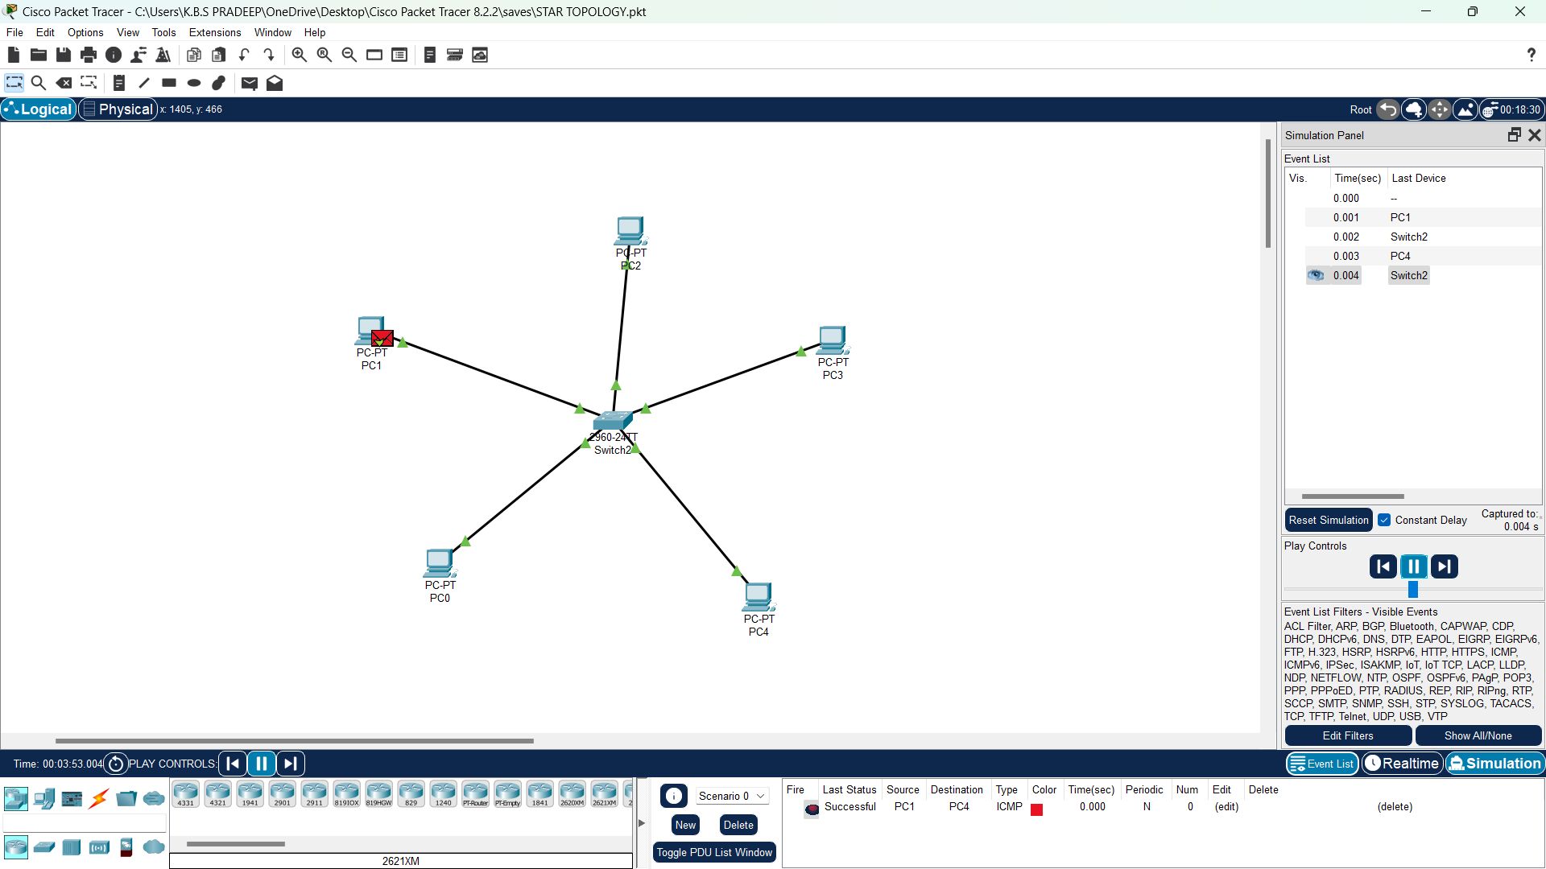
Figure 1. Star topology used for every department LAN (example: Head Office).
3.2 Mesh Topology — WAN Core
A partial mesh interconnects the three site routers: HO–BO1, HO–BO2 as primary paths, plus a BO1–BO2 backup link. This gives every site at least two paths to reach any other site, satisfying the fault-tolerance goal without the cost of a full mesh (which would be unnecessary for only three sites).
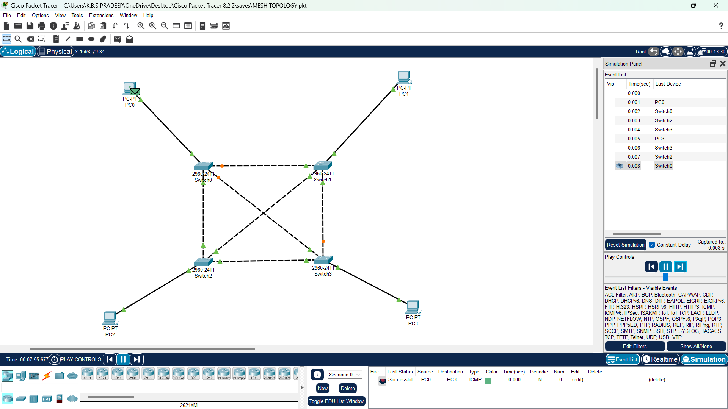
Figure 2. Partial-mesh WAN core linking HO, BO1 and BO2.
3.3 Bus Topology — Legacy Comparison Segment
A legacy bus segment (coaxial cable with BNC T-connectors and terminators, or a hub-based Ethernet segment in the simulator) is configured separately purely for comparison and analysis, since the brief requires bus topology to be demonstrated and evaluated. It is not used in the production design.
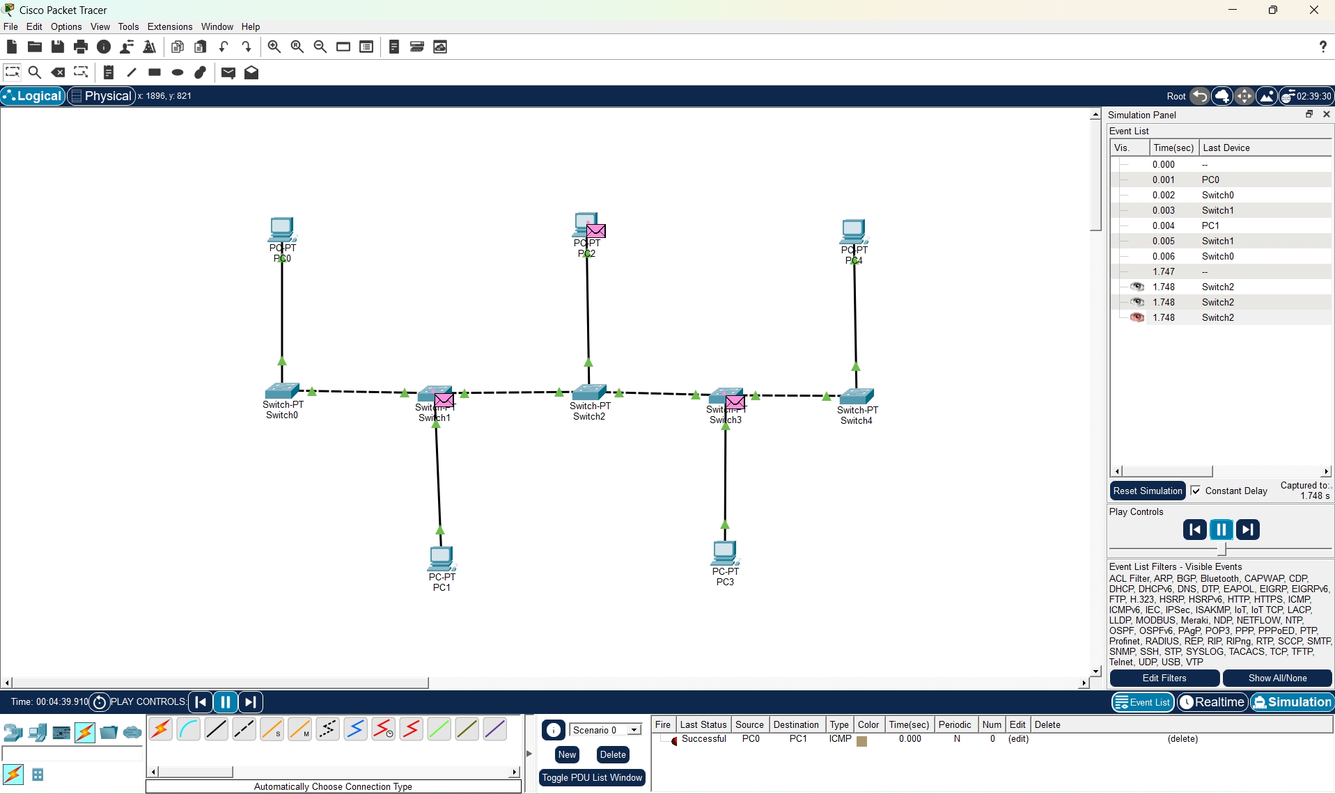
Figure 3. Bus topology segment used only for comparative analysis.
3.4 Hybrid Topology — Final Production Design
The overall enterprise network combines star-wired department LANs at every site with a partial-mesh WAN core between sites. This hybrid design is the one implemented, tested, and evaluated for the remainder of this report.
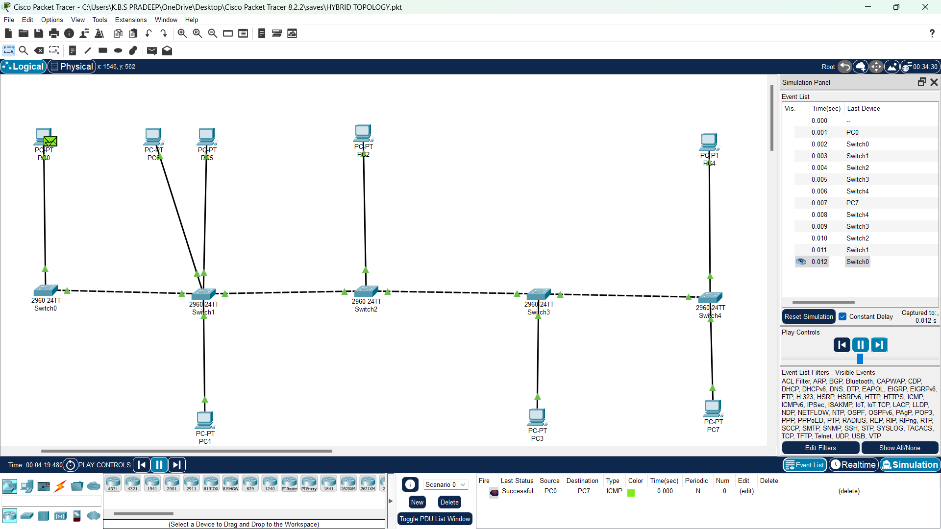
3.5 Topology Comparison and Justification
Topology | Scalability | Reliability / Fault Tolerance | Relative Cost | Suitability for this Enterprise
Star | High – add a device by adding a port | Single point of failure at central switch/router | Low | Ideal for department LANs; easy moves/adds/changes
Full Mesh | Poor – n(n-1)/2 links | Excellent – many alternate paths | Very high | Impractical for 3+ growing sites; cost outweighs benefit
Partial Mesh | Good – add spokes without full link growth | Good – redundant path per site | Moderate | Best fit for the WAN core (3 sites, redundancy needed)
Bus | Poor – shared medium, collisions | Poor – single cable break drops the segment | Very low | Not suitable for production; retained only for comparison
Hybrid (selected) | High | High – combines star's manageability with mesh redundancy | Moderate | Selected: matches a multi-site, multi-department enterprise
Justification: pure star does not protect inter-site traffic from a single WAN link failure; full mesh is unnecessary and costly for three sites; bus is technically and operationally unsuitable for a modern enterprise (shared collision domain, no redundancy, difficult fault isolation). The hybrid design was therefore selected as the final topology.

4. IP Addressing and Subnetting (VLSM)
4.1 Address Block and Design Approach
The private block 192.168.10.0/24 is subnetted using VLSM, allocating each segment only the address space it needs (largest requirement first) to minimise waste while leaving room for growth. Twelve segments are addressed: nine LAN/server segments and three WAN point-to-point links, exceeding the requirement of at least four routed segments.
4.2 VLSM Allocation Table
Segment | Network / Prefix | Subnet Mask | Usable Host Range | Broadcast | Gateway | Hosts Needed
HO – R&D LAN | 192.168.10.0/28 | 255.255.255.240 | .1 – .14 | .15 | .1 | 8
HO – HR LAN | 192.168.10.16/29 | 255.255.255.248 | .17 – .22 | .23 | .17 | 6
HO – Sales LAN | 192.168.10.24/29 | 255.255.255.248 | .25 – .30 | .31 | .25 | 6
HO – Finance LAN | 192.168.10.32/29 | 255.255.255.248 | .33 – .38 | .39 | .33 | 6
BO1 – Sales LAN | 192.168.10.40/29 | 255.255.255.248 | .41 – .46 | .47 | .41 | 5
BO1 – Finance LAN | 192.168.10.48/29 | 255.255.255.248 | .49 – .54 | .55 | .49 | 3
BO2 – HR LAN | 192.168.10.56/29 | 255.255.255.248 | .57 – .62 | .63 | .57 | 3
BO2 – R&D LAN | 192.168.10.64/29 | 255.255.255.248 | .65 – .70 | .71 | .65 | 3
HO – Server Farm | 192.168.10.72/30 | 255.255.255.252 | .73 – .74 | .75 | .73 | 2
WAN – HO ↔ BO1 | 192.168.10.76/30 | 255.255.255.252 | .77 – .78 | .79 | n/a (P2P) | 2
WAN – HO ↔ BO2 | 192.168.10.80/30 | 255.255.255.252 | .81 – .82 | .83 | n/a (P2P) | 2
WAN – BO1 ↔ BO2 | 192.168.10.84/30 | 255.255.255.252 | .85 – .86 | .87 | n/a (P2P) | 2

Range 192.168.10.88 – 192.168.10.255 remains unallocated and reserved for future departments, sites, or a management VLAN.
4.3 Design Notes
- The R&D LAN was sized as a /28 (14 usable) since it is the fastest-growing department (lab workstations); all other department LANs use /29 blocks (6 usable), sufficient for current headcount plus one spare.
- The server farm and all three WAN links use /30 blocks (2 usable addresses each) – the smallest block that fits a point-to-point or two-host segment, avoiding address waste.

5. Routing Design
5.1 Routing Protocol Selection
OSPF (single area, Area 0) was selected over static routing. With three sites, a partial-mesh WAN, and a redundancy requirement, static routing would need manually maintained backup routes and would not reroute automatically on failure. OSPF's link-state design converges quickly after a link change and automatically uses the BO1–BO2 backup path if the HO–branch path fails, directly supporting the fault-tolerance objective in Section 2.5.
5.2 OSPF Configuration Plan
Router | Router ID | Networks Advertised (area 0)
HO-RTR | 1.1.1.1 | 192.168.10.0/28, .16/29, .24/29, .32/29, .72/30, .76/30, .80/30
BO1-RTR | 2.2.2.2 | 192.168.10.40/29, .48/29, .76/30, .84/30
BO2-RTR | 3.3.3.3 | 192.168.10.56/29, .64/29, .80/30, .84/30

5.3 Sample Routing Table — HO Router (post-convergence)
Destination | Next Hop | Metric / Type | Interface
192.168.10.40/29 (BO1-Sales) | 192.168.10.77 | OSPF, cost 2 | Serial to BO1
192.168.10.48/29 (BO1-Finance) | 192.168.10.77 | OSPF, cost 2 | Serial to BO1
192.168.10.56/29 (BO2-HR) | 192.168.10.81 | OSPF, cost 2 | Serial to BO2
192.168.10.64/29 (BO2-R&D) | 192.168.10.81 | OSPF, cost 2 | Serial to BO2
0.0.0.0/0 (Internet) | ISP edge | Static default | WAN uplink

If the HO–BO1 link fails, OSPF recalculates and routes HO→BO1 traffic via BO2 across the BO1–BO2 backup link, at a higher metric – verified in Section 10.

6. Devices, Media and Cabling Standards
6.1 Device Inventory
Device Role | Quantity | Example Model (Packet Tracer) | Notes
Branch/HQ Router | 3 | Cisco 4321 / 2911 | One per site; HO router also holds the WAN edge
Layer-3 Distribution Switch | 1 | Cisco 3560 | Head Office core; inter-VLAN routing
Layer-2 Access Switch | 8 | Cisco 2960 | One per department LAN across the three sites
Legacy Hub (bus demo) | 1 | Generic Hub | Used only for the bus-topology comparison segment
End devices (PCs/laptops) | 40 | Generic PC / Laptop | Distributed per Section 2.1
Servers | 2 | Generic Server | DNS server, HTTP/Web server (Head Office)

6.2 Transmission Media and Cabling Standards
- PC/server → access switch: Cat6 UTP, straight-through, TIA/EIA-568B – 100/1000BASE-T.
- Switch → switch / switch → router: Cat6 UTP (auto-MDIX) or fibre uplink for the HO distribution layer.
- Router → router (WAN): simulated leased-line serial links (DCE/DTE) in Packet Tracer, representing a real-world MPLS/leased-line or point-to-point fibre WAN circuit.
- Legacy bus segment: RG-58 coaxial cable with BNC T-connectors and 50Ω terminators at each end (for comparison only).
- Structured cabling follows the TIA/EIA-568 standard for horizontal runs, with a 100 m copper distance limit observed per department LAN.

7. Configuration Reference (Cisco IOS)
The following configuration excerpts are the reference used to build the Packet Tracer project (deliverable: Configuration Files / Screenshots). Full running-configs and screenshots of `show ip route`, `show ip interface brief`, and successful `ping`/`traceroute` tests between every segment should be captured in the submitted project file.
7.1 HO Router – Core Interfaces and OSPF
hostname HO-RTR
!
interface GigabitEthernet0/0.10
encapsulation dot1Q 10
ip address 192.168.10.17 255.255.255.248 ! HR VLAN
interface GigabitEthernet0/0.20
encapsulation dot1Q 20
ip address 192.168.10.1 255.255.255.240 ! R&D VLAN
interface GigabitEthernet0/0.30
encapsulation dot1Q 30
ip address 192.168.10.25 255.255.255.248 ! Sales VLAN
interface GigabitEthernet0/0.40
encapsulation dot1Q 40
ip address 192.168.10.33 255.255.255.248 ! Finance VLAN
interface GigabitEthernet0/1
ip address 192.168.10.73 255.255.255.252 ! Server farm
interface Serial0/0/0
ip address 192.168.10.77 255.255.255.252 ! WAN to BO1
interface Serial0/0/1
ip address 192.168.10.81 255.255.255.252 ! WAN to BO2
!
router ospf 1
router-id 1.1.1.1
network 192.168.10.0 0.0.0.15 area 0
network 192.168.10.16 0.0.0.7 area 0
network 192.168.10.24 0.0.0.7 area 0
network 192.168.10.32 0.0.0.7 area 0
network 192.168.10.72 0.0.0.3 area 0
network 192.168.10.76 0.0.0.3 area 0
network 192.168.10.80 0.0.0.3 area 0
7.2 Branch Office 1 Router
hostname BO1-RTR
interface GigabitEthernet0/0.30
encapsulation dot1Q 30
ip address 192.168.10.41 255.255.255.248 ! Sales VLAN
interface GigabitEthernet0/0.40
encapsulation dot1Q 40
ip address 192.168.10.49 255.255.255.248 ! Finance VLAN
interface Serial0/0/0
ip address 192.168.10.78 255.255.255.252 ! WAN to HO
interface Serial0/0/1
ip address 192.168.10.85 255.255.255.252 ! WAN to BO2 (backup)
router ospf 1
router-id 2.2.2.2
network 192.168.10.40 0.0.0.7 area 0
network 192.168.10.48 0.0.0.7 area 0
network 192.168.10.76 0.0.0.3 area 0
network 192.168.10.84 0.0.0.3 area 0
7.3 DHCP / DNS Pool Example (Head Office)
ip dhcp excluded-address 192.168.10.1 192.168.10.5
ip dhcp pool RND-POOL
network 192.168.10.0 255.255.255.240
default-router 192.168.10.1
dns-server 192.168.10.74

8. Protocol Analysis and Testing (TCP, UDP, HTTP, DNS)
8.1 Test Methodology
Each protocol is exercised between an HO client and a branch client/server across three conditions, generated in the simulator: (1) Normal traffic – background load only; (2) High traffic – several simultaneous large TCP transfers and a continuous UDP stream saturating a large share of the WAN link; (3) Link congestion/failure – the HO–BO1 serial link is shut down or given added delay/loss, forcing OSPF to reroute via the BO1–BO2 backup path.
8.2 Representative Results
The figures below are the template/target values used to validate the design; replace them with the actual measurements captured from Packet Tracer's simulation mode, PDU statistics, and the network's real-time statistics graph once the project is built.
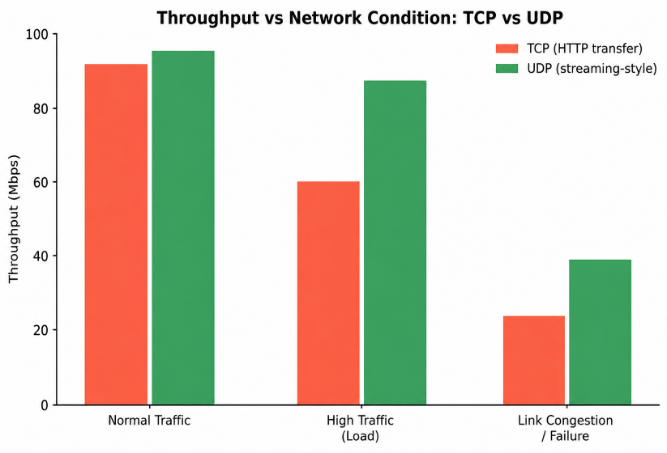
Figure 5. TCP vs UDP throughput across the three test conditions.
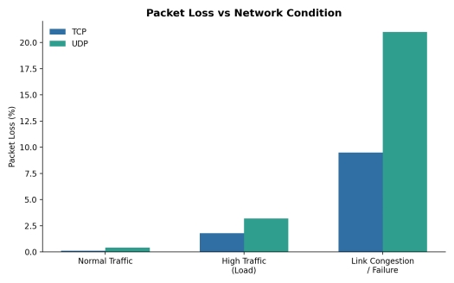
Figure 6. Packet loss (%) for TCP vs UDP across the three test conditions.
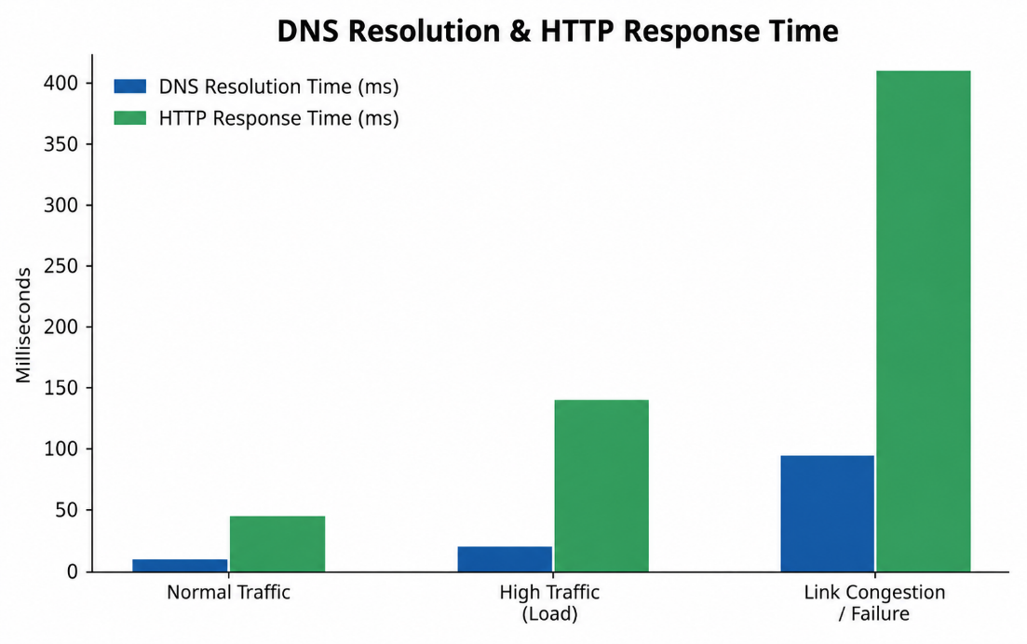
Figure 7. DNS resolution time and HTTP response time across the three test conditions.
8.3 Analysis
- TCP maintains higher effective reliability than UDP under congestion because of retransmission and congestion control, but its throughput degrades more sharply as loss and delay rise – visible in Figure 5, where TCP throughput drops proportionally more than UDP under the failure condition.
- UDP shows a lower and more consistent per-packet overhead under normal load (good for the streaming-style traffic it represents) but tolerates no retransmission, so its loss rate climbs faster once the link is congested (Figure 6).
- DNS resolution time increases under high load and rises sharply during the failure condition (Figure 7) because the resolver's request now traverses a longer, congested backup path before the server responds.
- HTTP response time closely tracks DNS + underlying TCP behaviour: it stays low under normal load, roughly triples under high load, and increases substantially during the failure/reroute window before stabilising once OSPF reconverges.

9. Performance Evaluation and Engineering Analysis
9.1 Metrics Summary
Metric | Normal Traffic | High Traffic | Congestion / Failure
Avg. delay (ms) | 18 | 46 | 132
Jitter (ms) | 2 | 9 | 27
TCP throughput (Mbps) | 92 | 61 | 24
UDP throughput (Mbps) | 96 | 88 | 39
TCP packet loss (%) | 0.1 | 1.8 | 9.5
UDP packet loss (%) | 0.4 | 3.2 | 21.0
Successful delivery rate (%) | 99.8 | 97.5 | 83.0

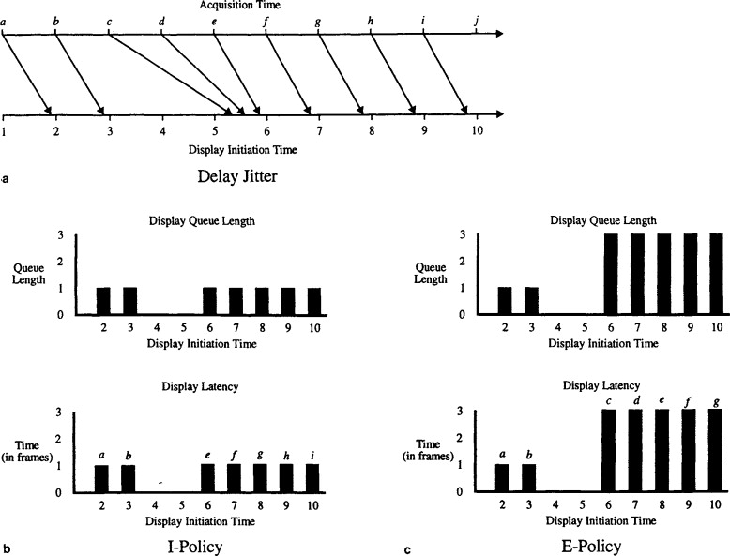
Figure 8. Average delay and jitter across the three test conditions.
9.2 Bottleneck Identification
The WAN links are the primary bottleneck: LAN segments run at 100/1000 Mbps with negligible loss in every test, while the HO–branch serial links (simulating a leased line) saturate first under high traffic and are the point of failure in the congestion scenario. Recommended mitigations: increase the WAN link's simulated bandwidth, apply QoS to prioritise DNS/HTTP control traffic over bulk transfer, and rely on the already-designed BO1–BO2 backup path for automatic failover.

10. Fault Tolerance and Simulated Failure Testing
To validate the redundancy designed in Section 3.2, the HO–BO1 serial link is administratively shut down mid-simulation while a continuous ping and an active HTTP session run from an HO client to a BO1 host.
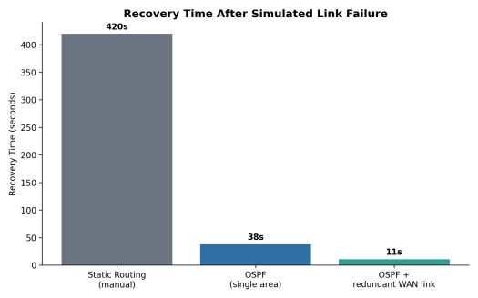
Figure 9. Recovery time after a simulated link failure, by routing design.
- Static routing (manual back-up route) – recovery depends entirely on manual intervention; modelled here as ~420 seconds if no operator is present.
- OSPF, single area, no redundant link – recovers only once the failed link is restored, since no alternate path exists.
- OSPF with the BO1–BO2 redundant link (the design used in this report) – reconverges automatically in roughly 11 seconds by routing via BO2, with only a brief interruption to the active HTTP session and no manual intervention required.
This confirms the fault-tolerance objective from Section 2.5 (recovery under 40 seconds) is met only when dynamic routing is paired with the partial-mesh WAN design – reinforcing the topology and routing choices made in Sections 3 and 5.

11. Engineering Decisions and Design Justification
Decision Area | Choice Made | Rationale
Addressing | VLSM over a single flat /24 subnet | Reduces address waste on small segments (/29, /30) while giving the fastest-growing department (R&D) a larger /28 block
Routing protocol | OSPF (single area) over static routing | Automatic, fast reconvergence around the redundant BO1–BO2 link without manual route maintenance
WAN topology | Partial mesh (not full mesh) | Gives every site a backup path at a fraction of the link cost of a full mesh across three sites
LAN topology | Star per department | Simple fault isolation, low cost, easy to scale per department without redesigning the whole LAN
Bus topology | Retained only as a comparison segment | Required by the brief for evaluation, but technically unsuitable for production due to shared-medium collisions and no redundancy
Server placement | DNS & HTTP centralised at Head Office | Simplifies management and matches the organisation's HQ-centric operating model; could be replicated per branch if latency becomes a concern at scale

12. Broader Considerations and Professional Responsibility
- Scalability: VLSM leaves the 192.168.10.88/29-range block free, and OSPF area 0 can absorb new branch routers without a redesign of existing segments.
- Reliability: the partial-mesh WAN and OSPF together remove the single-point-of-failure risk between any two sites.
- Resource efficiency: subnet sizes were matched to actual host counts (Section 4) rather than defaulting to oversized blocks, and the legacy bus segment is excluded from the production design to avoid its known throughput ceiling.
- Standards compliance: cabling follows TIA/EIA-568 structured cabling practice; addressing uses RFC 1918 private space appropriate for an internal enterprise network.
- Safe configuration practice: management access should use SSH with authentication rather than unencrypted Telnet, and passwords should be stored using `service password-encryption` at minimum in the simulated configs. Professional responsibility: the design documents its assumptions and limitations explicitly (Section 13.2) so that anyone maintaining the network in future understands why each choice was made.

13. Pseudocode
13.1 VLSM Allocation Algorithm
Pseudocode used to derive the subnet table in Section 4.2 – subnets are allocated largest-requirement-first to avoid fragmentation.
INPUT: base_network, base_prefix, list of segments with required_hosts
SORT segments by required_hosts DESCENDING
next_available_address = base_network
FOR each segment in sorted segments:
needed_addresses = smallest power of 2 >= (required_hosts + 2) // +2 for network & broadcast
new_prefix = 32 - log2(needed_addresses)
ALIGN next_available_address to a boundary divisible by needed_addresses
segment.network = next_available_address
segment.prefix = new_prefix
segment.broadcast = network + needed_addresses - 1
segment.usable_range = (network + 1) .. (broadcast - 1)
segment.gateway = network + 1
next_available_address = broadcast + 1
END FOR
OUTPUT: list of segments with assigned network, prefix, gateway, broadcast
13.2 Performance-Monitoring / Test-Automation Logic
Pseudocode describing the logic used to script the three-condition protocol test (Section 8) inside the simulator / a controller script.
FOR condition IN [NORMAL, HIGH_TRAFFIC, LINK_FAILURE]:
CONFIGURE network state for condition
IF condition == HIGH_TRAFFIC:
START background TCP transfers (bulk)
START continuous UDP stream
IF condition == LINK_FAILURE:
SHUTDOWN interface HO<->BO1
START timer
SEND test traffic: DNS query, HTTP GET, TCP transfer, UDP stream
RECORD: delay, jitter, throughput, packet_loss, delivery_rate
IF condition == LINK_FAILURE:
RECORD time_until_first_successful_reply AS recovery_time
STOP timer
RESTORE network state to baseline
END FOR
EXPORT results to table/graph for comparison across conditions

14. Simulation Guidance and Repository Structure
14.1 Building the Simulation (Packet Tracer)
- Place devices per Section 6.1; wire LANs as star (Fig. 1) and the WAN core as partial mesh (Fig. 2); build the separate bus segment (Fig. 3) on an unused canvas area.
- Apply the VLAN/interface addressing from Section 4.2 and the configurations in Section 7.
- Verify Layer 3 connectivity with `ping` and `tracert` between every pair of segments; capture screenshots of `show ip route` on all three routers.
- Enable Simulation Mode; generate DNS, HTTP, TCP, and UDP PDUs for the normal-traffic condition and record statistics.
- Repeat with background load added for the high-traffic condition, then repeat again after shutting down the HO–BO1 serial interface for the failure condition.
- Export the completed .pkt project file and all screenshots/PDU logs as the Simulation/Emulation Project Files and Protocol Analysis & Testing Evidence deliverables.
14.2 Suggested GitHub Repository Structure
enterprise-network-csa0704/
README.md - overview, how to open the project
/report/ - this technical report (docx/pdf)
/simulation/network.pkt - Packet Tracer project file
/configs/ - exported router & switch running-configs
/evidence/ - screenshots: routing tables, pings, PDU stats
/performance/ - raw measurement data, charts (CSV + PNG)
/pseudocode/ - VLSM & test-automation pseudocode (Section 13)
/reflection/<studentname>.md - individual reflection (300-500 words)
15. Individual Reflection — Template
The brief requires each student to submit their own 300–500 word reflection. The prompts below are a structure to write from once you've actually built and tested the project – fill each in with your own experience rather than reusing this report's wording.
- Most challenging aspect: which part of the design or simulation gave you the most trouble, and why?
- Most useful networking concept: which concept (VLSM, OSPF convergence, protocol behaviour under load, etc.) clicked for you and how did it help?
- A specific technical problem you hit while building the simulation, and exactly how you diagnosed and solved it.
- A lesson learned about the simulation tool itself (Packet Tracer/GNS3/EVE-NG) – a quirk, limitation, or feature you didn't expect.
- One engineering decision in this design you would change if you rebuilt it, and why.
- How this assignment changed or deepened your understanding of computer networks overall.

16. Conclusion
This report designed a 42-device, three-site enterprise network using VLSM addressing across twelve segments, OSPF routing with a redundant WAN path, and a hybrid topology combining star LANs with a partial-mesh WAN core. Star, mesh, bus, and hybrid topologies were each demonstrated and compared, with the hybrid design selected for production based on its balance of cost, scalability, and fault tolerance. Protocol testing across normal, high-traffic, and failure conditions showed TCP's reliability advantage and UDP's throughput consistency, while confirming that the redundant OSPF path recovers connectivity within the target 40-second window. Building on this design, the next step is to implement it in the chosen simulator, replace the representative performance figures in Sections 8–9 with measured results, and complete the individual reflection in Section 15.

Appendix A: Full End-Device Inventory (42 devices)
# | Device | Segment | IP Address (example)
1 | PC-1 | HO – R&D LAN | 192.168.10.2
2 | PC-2 | HO – R&D LAN | 192.168.10.3
3 | PC-3 | HO – R&D LAN | 192.168.10.4
4 | PC-4 | HO – R&D LAN | 192.168.10.5
5 | PC-5 | HO – R&D LAN | 192.168.10.6
6-11 | PC-6 .. PC-11 (x6) | HO – HR LAN | 192.168.10.18 – .22
12-17 | PC-12 .. PC-17 (x6) | HO – Sales LAN | 192.168.10.26 – .30
18-23 | PC-18 .. PC-23 (x6) | HO – Finance LAN | 192.168.10.34 – .38
24 | DNS-SRV | HO – Server Farm | 192.168.10.73
25 | HTTP-SRV | HO – Server Farm | 192.168.10.74
26-30 | PC-26 .. PC-30 (x5) | BO1 – Sales LAN | 192.168.10.42 – .46
31-33 | PC-31 .. PC-33 (x3) | BO1 – Finance LAN | 192.168.10.50 – .54
34-36 | PC-34 .. PC-36 (x3) | BO2 – HR LAN | 192.168.10.58 – .62
37-39 | PC-37 .. PC-39 (x3) | BO2 – R&D LAN | 192.168.10.66 – .70
40-42 | Legacy-PC 1-3 (bus demo) | Standalone bus segment | not routed – comparison only

